Ideation Phase

Define the Problem Statements

|  |  |
| --- | --- |
| Date | 27 June 2025 |
| Team ID | LTVIP2025TMID31213 |
| Project Name | Edututor-AI-Personalized-Learning-withGenerative-AI-and-LMS-Integration |
| Maximum Marks | 2 Marks |

Customer Problem Statement Template:

1. Specific Problem: Clearly define the problem.
2. Customer Perspective: Understand the customer's needs and pain points.
3. Impact: Quantify the impact of the problem.
4. Current Challenges: Identify current challenges or workarounds.
5. Desired Outcome: Describe the desired solution or outcome.

Benefits

1. Clear Understanding: Clearly understand the customer's problem.
2. Effective Solution: Develop an effective solution that meets customer needs.
3. Improved Customer Satisfaction: Improve customer satisfaction by addressing their pain points.

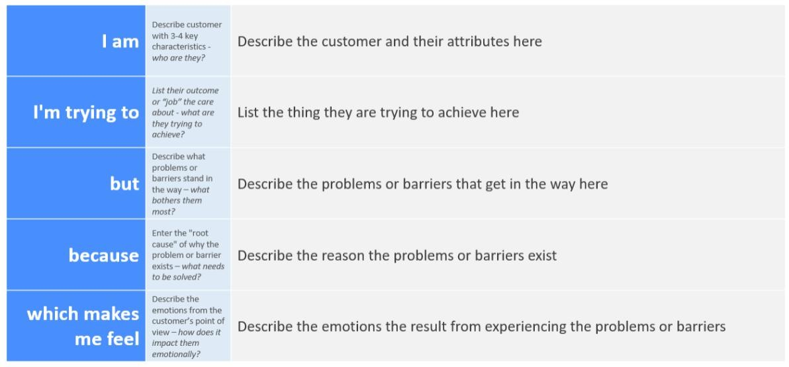

Reference: <https://miro.com/templates/customer-problem-statement/>

Example:

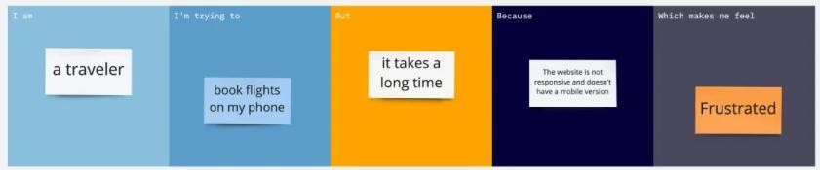

|  |  |  |  |  |  |
| --- | --- | --- | --- | --- | --- |
| Problem  Statement  (PS) | I am  (Customer) | I’m trying to | But | Because | Which makes me feel |
| PS-1 | a college student preparing for competitive exams | get personalized guidance and practice questions suited to my weak areas | the current LMS only provides static notes and generic quizzes | it does not use AI to analyze my progress or adapt to my learning needs | stressed, unsupported, and anxious about falling behind |
| PS-2 | a school teacher managing multiple students with different learning paces | offer individualized  feedback and  tailor learning materials for each student | my LMS  lacks integration with AI tools that can automate content generation and analysis | it’s time-  consuming to manually create personalized resources for every student | overwhelmed,  inefficient, and concerned about student outcomes |